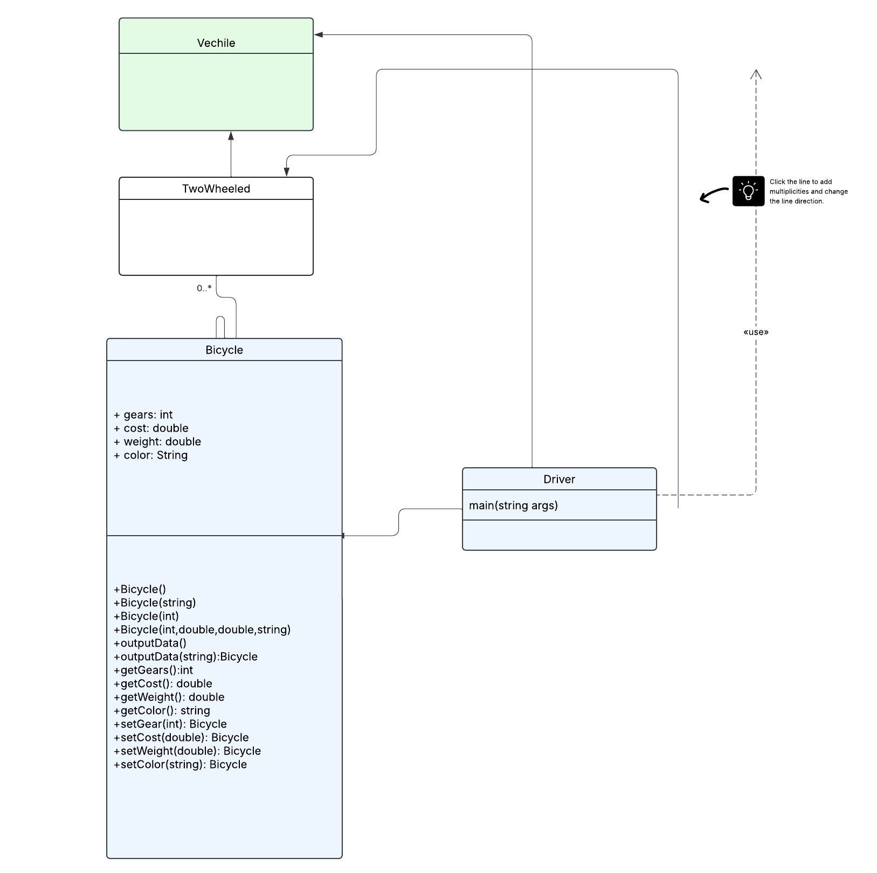
In the inheritance-based class diagram above, Bicycle is descended from TwoWheeled, while TwoWheeled is descended from Vehicle. As a result, the classes can inherit the properties of the classes from which they originated. By keeping the data private and utilising public methods to access it, the diagram also demonstrates encapsulation (-). General classes like Vehicle and TwoWheeled are used to demonstrate abstraction and enable feature sharing. When the Bicycle object can be viewed as a TwoWheeled object, polymorphism is demonstrated. Flexibility and reusable code are thus made possible. When taken as a whole, the diagram effectively illustrates object-oriented programming concepts.

